It is a top down platforming game. You play as a bomb who can’t explode! You use other fellow bombs to propel you to new locations. They have a short fuse so you have to position yourself before they explode and if you don’t you may just die.

Game mechanics:

Jumping- via enemies

Walking- It’ll be a slower walk but you can turn a lot better walking

Running- You’ll be able to move fast but not turn as well.

Fall to your death

Moving platforms

Jump pads

Swinging obstacles

Enemies:

Just a simple bombomb type character who walks up and explodes but they are also used to move you vertically.

Trap doors & walls

Swinging hammers or axes

Hard platforming

Camera:

Camera will be fixed and at the angle of Link’s Awakening

It will have a fixed point like super Mario 3d world

Level Design:

A cross between Fall guys obstacle course and Link’s awakening temples

Wipeout has some good level design

It will use camera angle as a tool for puzzles like Captain toad’s treasure tracker

Super Mario 3d world level 1-1- I like the locked down camera in most of this game. It’ll need to be adjusted and locked down a little more. (0:20 – 1:00)

<https://www.youtube.com/watch?v=0_k_UeDVuao>

Link’s Awakening turtle shrine – I like the vertical puzzle demonstration for this camera view (20:00 – 20:53, 30:25 – 31:30)

<https://www.youtube.com/watch?v=1yq-dezuXJg>

A link between world’s wind shrine – Another great use of vertical layers. (4:30 – 7:00)

<https://www.youtube.com/watch?v=QcTsIMelezA>

Mario 64: Bomb omb battlefield- The idea for the enemy but using the bombs to move around a bit more (0:35 – 2:30)

<https://www.youtube.com/watch?v=mHBfzdUC2EU>

Wipeout obstacle course- More great examples of obstacle course design (1:20 – 5:00)

<https://www.youtube.com/watch?v=MqGh1sTpZPg>

Wipeout obstacle course002- obstacle course design

<https://www.youtube.com/watch?v=L6xyKDYsanQ>

Crash Bandicoot bridge level - Good example of fixed camera with 3d platforming (9:32 – 15:00)

<https://www.youtube.com/watch?v=xpIUkUd1MqE>

Pictures:

Some Ideas for character and enemy design

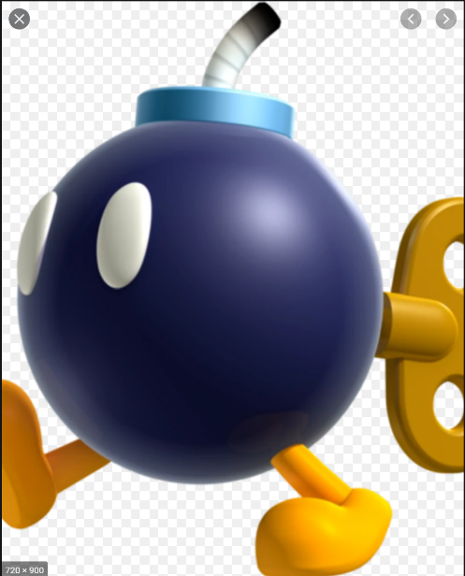

View of camera angles:

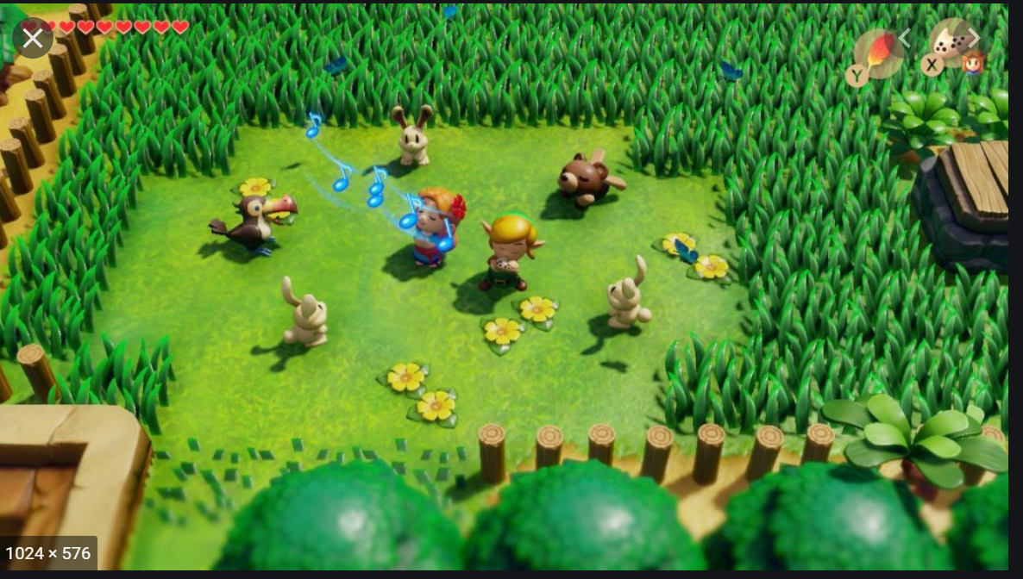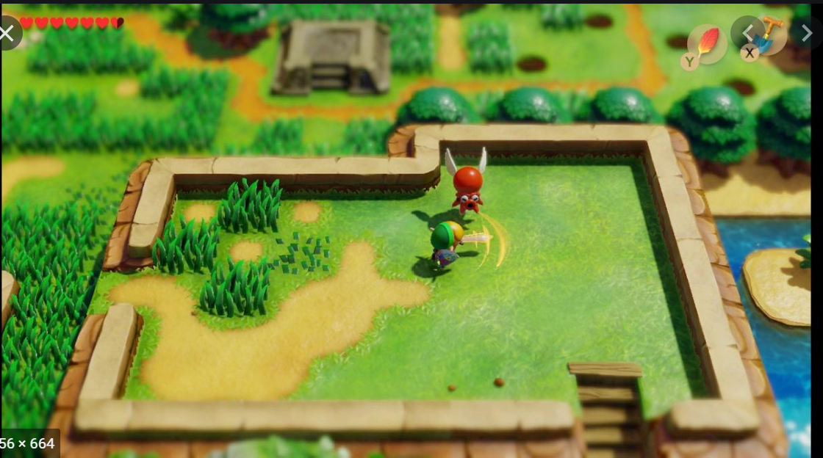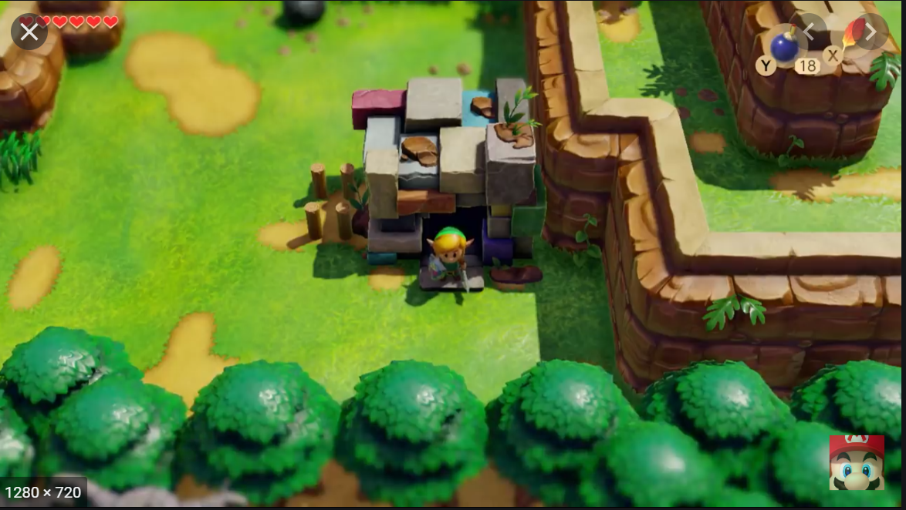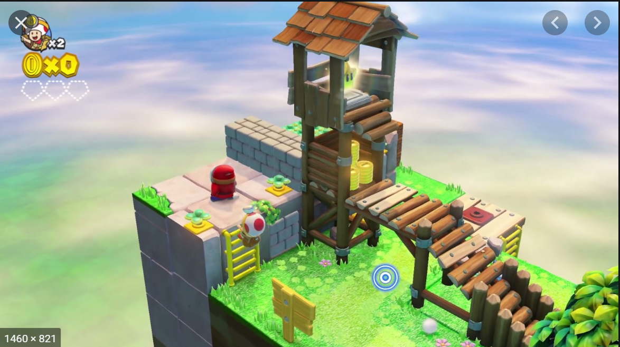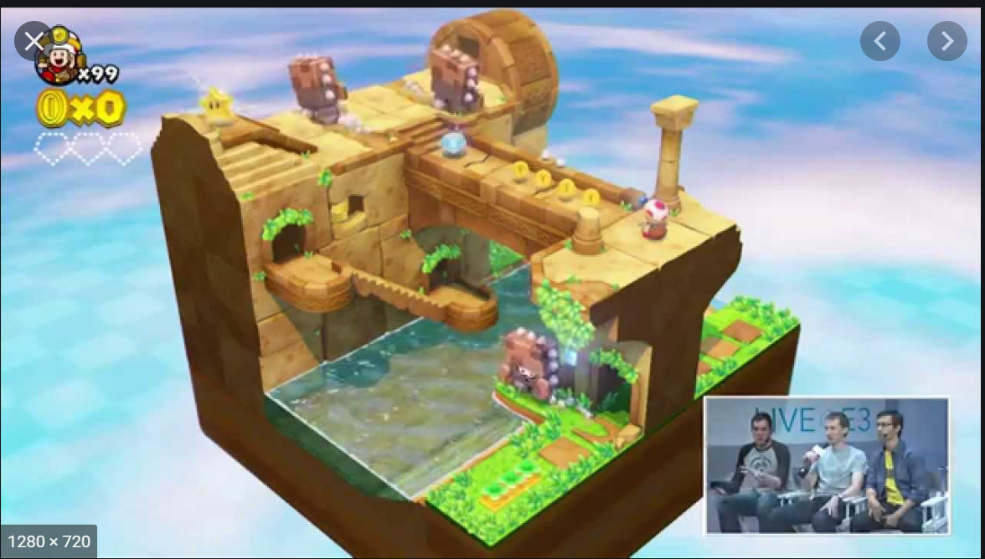

Examples of fixed camera platforming: